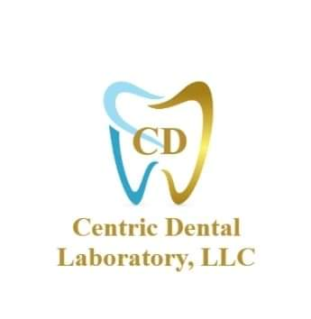

**Immediate Denture**

(Patient has Teeth)

Is the Correct Anatomy Captured

on the Impression or Scan?

Yes No

Are there enough Proceed with

Teeth on the upper/lower Custom Tray Impression(s)

Arches to capture Occlusion?

Yes No Are there enough teeth

On the upper/lower

Arches to capture occlusion?

Proceed to Proceed to

Completion / Wax Rim(s)

Process Yes No

Is the patient Proceed to Proceed to

Missing 4 or Completion / Wax Rim(s)

More ANTERIOR Process

Teeth?

Is the patient missing

Yes No 4 or more ANTERIOR

Teeth?

Wax Try-in Proceed to

w/ Teeth for Completion / Yes No

ANTERIOR TEETH Process

Only Wax Try-in W/ Teeth Proceed to

For ANTERIOR TEETH Completion /

Proceed to only Process

Completion /

Process

Proceed to

Completion / Process